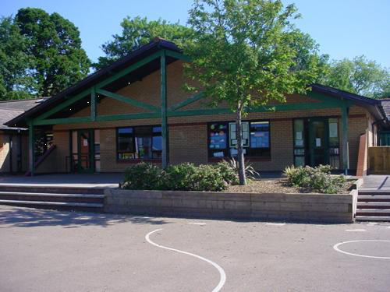

**Health and Wellbeing**

Daily Mile 12-15 mins of daily exercise

Weekly play to Learn Multiskills games and skills linked with Dinosaur stories and songs.

Evaluate our practical work

Support Children in Need 17.11.17

Growth Mindset skills for our classroom and learning.

Keeping Safe with PC Cath (stranger danger)

**Expressive Arts**

Let’s create a dinosaur song!

Let’s create Dino puppets using socks!

How do dinosaurs move and battle?

How can we create a dinosaur out of junk?

What do we need to create a dinosaur egg?

How do we create a digital dinosaur movie using flipogram?

**Humanities**

What did our planet look like during prehistoric times?

How has life changed from the dinosaur age to today?

Why did the dinosaurs become extinct?

Christmas Celebrations, songs and play

**Maths and Numeracy**

Reasoning methods and practical exploration

Measuring Dinosaur footprints and bones

Sorting dinosaurs into groups, explaining their reasoning

Beebot – Co-ordinates – Dinosaur floor robot

Money – Rounding, comparing and ordering

Use triple cards/flapjacks/games to practise bonds within 10

Build multiplication facts for the x2 table

Add and subtract two 2 digit numbers by partitioning, using a bead bar and problem solving

**Language, Literacy and Communication**

Daily RWI, guided reading, spellings and extended writing activities

Instruction writing (make a Dinosaur puppet)

Use Non-fiction books and the web to find out key facts

Make notes and label diagrams of dinosaurs

Create a fact file and mini – information books about a chosen dinosaur

Make ‘Did you know…’ cards- Include descriptions, poems and rhymes about dinosaurs

Make a dinosaur word wall - Include similes

Tell dinosaur jokes and create a play using our puppets

**Science and Technology**

Sort dinosaurs into meat eaters and plant eaters

Go on a Plant walk

Make dinosaur models from recycled materials

Learn about Mary Anning and explore her fossil collection

Learn to make rubbings and sort accordingly?

Create a powerpoint slide show to present things that they have learned throughout the topic

Make a short, stop frame animation using dinosaur models

How have animals teeth changed over time?

What does a dinosaur skeleton look like?

Which plants still exist today from prehistoric times?

What ever happened to the Dodo bird?

**Welsh**

**Hwyl dan 7 – Gwyrdd**

Role play – Topic

Match pictures to sentences

Sorting positive and negative sentences

Rap – what they like/don’t like to do

**Dinosaur Planet**

**ROWAN CLASS**

**Memorable Experience –**

**Visit Dan yr Ogaf Show caves and Dinosaur World (13.12.17)**

**Home Learning Opportunities;**

Dinosaur fact finding, explore modern reptiles in a pet shop, seek out Dinosaur fact books, hunt for prehistoric that are around today, create a dinosaur mask, tell dinosaur stories to others, take part in a dinosaur reading challenge!