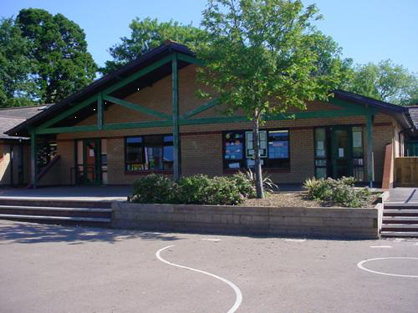
Language, Literacy and Communication
Daily RWI, guided reading, spellings and extended writing activities
Become a palaeontologist for the day
Use Non-fiction books and the web to find out key facts
Make notes and label diagrams of dinosaurs
Create a fact file and mini – information books about a chosen dinosaur
Make ‘Did you know…’ cards- Include descriptions, poems and rhymes about dinosaurs
Make a dinosaur word wall - Include similes
Welsh
Hwyl dan 7 – Gwyrdd
Role play – Topic
Match pictures to sentences
Sorting positive and negative sentences
Rap – what they like/don’t like to do
Maths and Numeracy
Measurement of dinosaurs – length, height, and distance
Weight/mass and capacity
Sort dinosaurs into groups, explaining their reasoning
Beebot – Co-ordinates – Dinosaur floor robot
Money – Rounding, comparing and ordering
Use triple cards/flapjacks/games to practise bonds within 10
Build multiplication facts for the x2 table
Add and subtract two 2 digit numbers by partitioning, using a bead bar and problem solving
Health and Wellbeing
Begin the daily Mile
Learn about healthy foods and their benefits
Reinforce “Growth Mindset” by spending time listening to the children and one another and respecting viewpoints – Introduce the concept that “we can’t do it YET!”
Supporting Children in Need – 17.11.17
Celebrating Christmas
Keeping safe – PC Cath Visit (Stranger danger)
Homework
1. Take Dino the Dinosaur home and write in his diary
2. Share stories and poems about dinosaurs with your grown-ups.
3. Create a dinosaur mask and bring it into school for a dinosaur parade.
4. Write about, draw and label your favourite dinosaur
5.

DINOSAUR PLANET
Topic 2 - YEAR 2
Memorable Experience –
Visit Dan yr Ogaf Show caves and Dinosaur World (13.12.17)
Humanities
Follow maps and plans when on a Dinosaur Hunt in the woods – Use grid references to find locations
Make up Dinosaur codes and create their own dinosaur language
Look at Dinosaur fossils and discover what the first and last dinosaurs were to roam the earth
Compare Earth to when dinosaurs roamed to present day
Science and Technology
Become a dinosaur dentist – sort to meat eaters and plant eaters- Go on a Plant walk
Make dinosaur models from recycled materials
Learn about Mary Anning and her Fossil collection Look at fossils and discuss texture and shape
Create a Powerpoint slide show to present things that they have learned throughout the topic
Make a short, stop frame animation using dinosaur models

Expressive Arts
Make music to accompany dinosaur chants, rhymes and poems
Create group Dinosaur dances – sequences of dinosaur movements with music
Create a prehistoric landscape for a dinosaur habitat
Host a dinosaur party. Include a puppet show, small world dinosaur area, invitations, seating planes, etc.
Make some Fossil rubbings and create a fossil park

