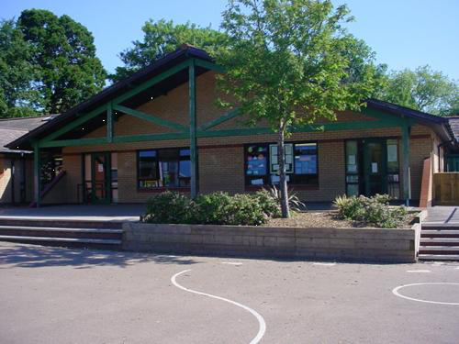

**Health and Wellbeing**

Learn the routines and independent skills of our new Nursery world.

Staying safe – handwashing, coughing etc.

Making friends and being a good friend

Learning about our faces, bodies, things that are the same and things that are different.

Cooking familiar foods.

Culturally relevant and topical resources in home corner to reflect the diversity of our world.   
Talk about what we are thankful for at Harvest time. Children in Need- learning about others who are not so fortunate.

*Our Wonderful World*

*Reception*

*Autumn Term 2020*

**Maths and Numeracy**

Counting with natural (seasonal) objects, measuring with sticks,

Autumn scavenger hunt (counting and size), sorting Autumn objects (data handling). Numbers in my world (my age, my birthday, my door number, how many in my house?)

Adopt a tree – observe the passage of time.

**Science and Technology**

How do animals behave in Autumn and Winter. Which animals live in our school and local environment?

How do trees and plants change at this time of year? Which plants can be found in our school and local environment?

Can you build familiar buildings from our local area?

**Welsh**

Say Hello and Goodbye

Answer the question ‘Pwy wyt ti?’- _________ ydw i.  
Counting – Sawl un? Rhifwch gyda fi…  
colours – Pa liw?

**Languages, Literacy and Communication**

Range of stories, including: Here We Are by Oliver Jeffers, Stanley’s Stick by John Hegley, The Gigantic Turnip by Aleksei Tolstoy, This Is Our House by Michael Rosen, There’s Going To Be A Baby by John Burningham, Our Favourite Day by Joowaon Oh, Biscuit Bear by Mini Grey, Happy Birthday Maisy by Lucy Cousins, Hello Friend by Rebecca Cobb, Jabari Jumps by Gaia Cornwall.

Writing/reading my name, names of family members and friend’s names.

Story telling – stories set in the worlds of our imagination.

Develop Mark Making skills.

**Humanities**

Explore seasonal changes in our local area.   
  
Talking about our own families and learning about others.   
  
Exploring how birthdays are celebrated  
  
Cultural celebrations: Bonfire night, Remembrance, Halloween, Harvest, Diwali, Advent, Christmas.

**Expressive Arts**

Using natural materials that we collect in our local area to create art (loose parts, using found materials to make marks).

Naming and mixing colours – link with Autumn

Exploring and using clay to recreate autumn/winter objects eg acorns, pine cones.  
Art/craft inspired by seasonal events making use of a range of techniques and materials.