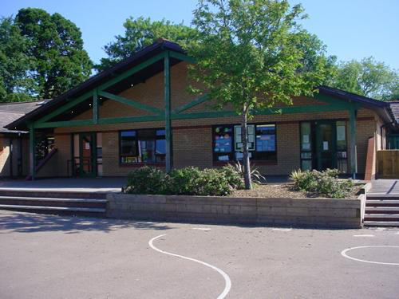

**Welsh**

Learn a range of Welsh songs and poems for the Eisteddfod.

Brilliant Betsi

Reception

**Homework**

1.Show your family how to wash their hands correctly.

2.Create your own delicious/disgusting medicine.

3. Keep a food diary.

4. Maths activities.

5. Draw/paint a picture of your favourite meal.

**Expressive Arts**

**Role play area-hospital/doctors surgery.**

**Eisteddfod.**

**Paint a picture of an emergency service worker or vehicle.**

**Humanities**

**Programme Beebot to visit places in the world that Betsi visited on a map.**

**Look at a map of Wales. Can we find Monmouth and Bala? We live in Monmouth, Betsi lived in Bala. Mark these on the map. Chinese New Year.**

**Health and Wellbeing**

Visit to hospital/health professional to visit school to talk about their job. Create questions to ask. Practise bandaging toys and dolls.

Healthy foods- healthy lunchbox/plate. Sorting healthy/unhealthy foods. How to keep our bodies healthy.

People who help us.

Explore the effects of exercise on our bodies.

**Maths and Numeracy**

Taking temperatures-recording results on a graph. Count in 10’s to 100. Count in 2’s to 10.Show finger patterns to 10. Introduce language of early multiplication by grouping. Use 5p and 1p coins to pay for items up to 10p. Combine 2 sets of objects within 10 to find how many altogether where the first collection is hidden. Subtract from a hidden collection up to 5. Recite forwards to 30 and backwards from 20.

**Science and Technology**

Germs and how they spread/handwashing. Order set of pictures for washing hands. Medicine safety. Make a poster using ICT. Recording temperatures on a graph.

Label the human body.

**Language, Literacy and Communication**

Listen to the story of Betsi Cadwaladr. Ask children to share ideas of what a nurse does. Make a list of items that a nurse may use/ explore/find out how would you use them? Talk about how to contact emergency services-who are they and what do they do?

Comparing a hospital in Betsi’s time and now.

Share stories- Nurse Clementine, Franklin goes to the hospital, Topsy and Tim go to the dentist/doctor, The Very Hungry Caterpillar, Oliver’s Vegetables.