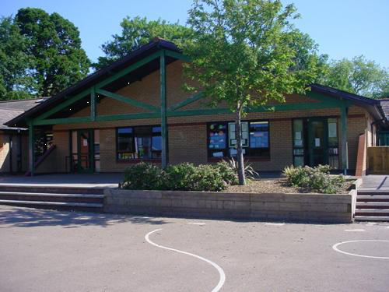

**Humanities**

Look at a map of the UK and track Betsi’s journey.   
SEAL – Getting on and falling out  
Chinese New Year

Qualities of a good friend – write recipes

**Expressive Arts**

Role Play – doctors/hospital  
Learn a range of songs/poems for Eisteddfod  
Paint a picture of an emergency service worker or emergency transport

Make spoon puppets of people who help us

**Welsh**

Learn a range of songs/poems for Eisteddfod Celebrations

Rite about where we are going and what we want and saw

Brilliant Betsi

Year 2

**Homework**

1. Be the teacher! Show your family how to wash their hands correctly

2. Create your own delicious or disgusting medicine

3. Find out about transport now and then

4. Write an acrostic poem about Betsi using her name

5.

**Health and Wellbeing**

Visit to hospital/talk by health professional. Create questions to ask.

First aider to visit and teach us some basics. Practise on teddies and dolls.

Difference between Victorian hospitals and current day hospitals.

Healthy foods to keep soldiers healthy

**Maths and Numeracy**

Explore capacity and standard measures using medicine spoons, cups, droppers, syringes etc.   
Take our temperatures and record the class results

Place value up to at least 100dding/subtracting 2 digit numbers

**Science and Technology**

Learn about germs and how they are spread – importance of washing hands.

Write sets of instructions for washing hands.

Safety around medicines – using ICT to create a poster about the dangers

Learn about mixtures and solutions

**Language, Literacy and Communication**

Read story of Betsi Cadwaladr and outline her story.

Read Nurse Clementine by Simon James – create a list of items nurses might use.

Talk about how to contact the emergency services. Discuss who they are and what they do.