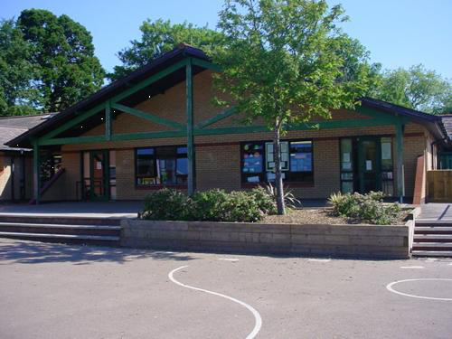

**Expressive Arts**

Drawings of lighthouses  
Messages in bottles – Creative displays

Draw treasure maps

Design our own pirate flag  
Sing sea shanties and sailor songs

Plan and organise a Pirate party – 16.05.19

Dress as a pirate and meet a real life Pirate

Sea life art – sharks, jellyfish, starfish etc.

Treasure hunt – Follow clues, take rubbings

Make ocean slime / use Jelly Baff/ Orbeez / blue spaghetti

Prepare and take part in the Year 2 Leavers assembly –on 12.07.19 at 2pm.

**Health and Wellbeing  
RNLI Visit – 13th May**

**Healthy Living Week – 3rd June**

**Sports Day – 4th June**

**Visit from a Pirate 16.05.19**

**Play Pirate games - Pirate’s Den and Keeper of the Keys**

**Discuss the environment - How to look after our planet**

**Homework**

1. **Design and make your own pirate boat and bring it into class**
2. **Write about a holiday destination of your choice, add illustrations and pictures**
3. **Create a shoe box aquarium**
4. **Find and learn some pirate jokes to share**
5. **Welsh – Label a pirate’s clothes**
6. **Maths – Create a treasure map and write a set of co-ordinates for your friends to follow.**

**Land Ahoy:**

**Year 1 & 2**

**Memorable Experience –**

**Pirate Day/Royal Mint Experience - Llantrisant**

**Maths and Numeracy**

Continue to practise reciting numbers up to 100/ beyond 100, forwards and backwards

Position and order 2/3 digit numbers in the range 100-200 using a bead bar, magic stick and a number line

Make connections with money and measures

Consolidate language of early multiplication making groups of…/Build multiplication facts for the x3 tables

Mentally add any multiple of 10 to any 2 digit number bridging 100

Use place value cards to add two single digit numbers bridging 10/ to add and subtract tens of hundreds from any 3 digit number

Follow and plan co-ordinates to find the treasure

Direct and control a beebot using directional language and coding skills

Focus on coins from the UK and abroad – Identify the value, find totals of two items bridging 10, make comparisons, find totals and give change

Strike own coin - Royal Mint Experience

Explore the capacity of items – Measure in non-standard units/ litres and millilitres

Use descriptive words for temperature/Compare daily temperatures

Extract and interpret information form lists, tables, graphs and diagrams

**Humanities**

**Map work including co-ordinates**

**Research famous pirates**

**Learn about the Titanic and its history**

**Coins from around the world**

**Holiday destinations – climate, weather, tourist attractions**

**Posters and power points in groups about chosen countries’**

**Welsh**Re- tell the story of selection of stories/Barti Ddu

Hobbies/interess and past times

Description of characters

Reading a selection of Welsh books

Hawl Dan 6/7

**Science and Technology**

Make circuits to light a lighthouse

Floating and sinking – best pirate boat

Explore density using salt water

Dissolving experiments

Make sundials

Finding magnetic materials

Directions using iPads and beebots

Research sea life using Chromebooks

**Language, Literacy and Communication**

Read, write, Inc sessions in differentiated groups

Guided reading groups/Individual Reading

Reading and retelling a selection of pirate stories

Wanted! Posters  
Explore what we would take to a desert island

Make up some secret pirate code and messages

Plan and write Pirate Party invites

Send postcards from around the world

Describe what we found in a pirate’s treasure chest

A selection of Pirate poetry

Writing messages in a bottle