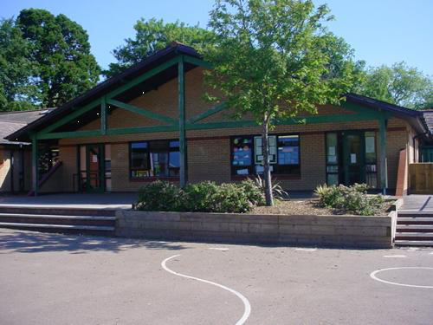

**Maths and Numeracy**

Recite numbers beyond 50/100, forwards, backwards

Partitioning teen numbers, partitioning 2 digit numbers,

Count and group in 2s, 5s and 10s

Combination of money up to 10p, up to £1

Count reliably up to 20 objects

Read and write numbers to 20

Graphs of weather

Measure rainfall and daily temperature

Add/subtract up to 10/add and subtract 11 from a given number

**Wriggle and Crawl**

**Year 1 & 2**

**Memorable Experience –**

**RSPB Visit**

**Homework**

Create a mini-beast home

3D model of a mini beast

Visit a library and find books about mini-beasts

Create a table of your favourite mini-beasts

Investigate your garden and write a list of mini-beasts you find

Welsh language homework – name parts of an insect body in Welsh

**Health and Wellbeing**

Class charter

SEAL – New Beginnings

Recycling and caring for our environment

Healthy eating

How to keep ourselves healthy

Mrs Tufty – road safety

**Expressive Arts**

Detailed sketches of mini-beasts

Make our own ant

Ugly Bug Ball

Mini-beast craft

Bug masks

Move like a mini-beast

Add tuned and percussion instruments to a class poem

**Language, Literacy and Communication**

Write a list in alphabetical order of mini beasts

Create an information page about a mini-beast to create a class book

Instructions to look after an animal

Write a film review

Read and listen to traditional poems

Write a class pledge

**Humanities**

Simple maps and plans

Life cycle of bees

Harvest activities

World War I week

**Welsh**

Evaluation and revision

Facts about us

Emotions

Weather and days of the week

**Science and Technology**

Match baby and adult mini beasts

Taste different types of honey

Label body parts of insects

An insect classification tree

Let’s Investigate – worms, snails and ladybirds

ICT – stop motion animation