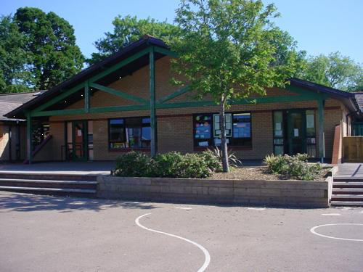

**Maths and Numeracy**

Read and write number words to 100/ read and write words to 10.

Compare and order 2 digit numbers, make connections with measure

Position measurements of length on a bead bar/ position numbers to 100 on the bead bar, making links with PV cards.

Compare measure to find the longest/shortest

Order a set of measures up to 1 metre

Use mental recall of number facts to 10 to derive bonds of 1000/ Keep bonds to 10 on the boil

Recall and use 2, 5 and 10 multiplication tables

Solve one and two step problems that involve addition, subtraction, multiplication and division/ Language of early division when sharing/ Find halves in practical situations.

Find totals from multiples of 10p/ pay for items to 20p using a combination of coins and give change from 10p.  
Doubles and halves to 10 & near doubles to 10.  
Use known facts when adding 3 single digit numbers.  
Estimate a number of objects to 20.  
Make whole turns and half turns.

**Ysgol: Year 1 & 2**

**Memorable Experience –   
St. Fagan’s visit**

**Humanities**

Maps and plans of the school  
History of the school – find out about our school and when it was built. Look at old pictures.   
Look at old books and resources.   
Look at school rules from Victorian times and compare them to our school rules.   
Look at other countries and whether children work or go to school. Visit St Fagan’s class for the day. Wear Victorian costume to school.

**Expressive Arts**

Design your own school logo and motto.  
Observational drawings of the school and the school environment.  
Chinese New Year/Easter/Valentines activities  
World Book Day  
Design your own uniform.

Music – create/learn our own school song

Dance – Traditional dances

Paintings of birds

Craft and modelling activities within Enhanced provision

**Welsh**

Beth wyt ti’n gwisgo? Ysgol  
Eisteddfod – Songs and poetry  
Welsh Week. Traditional stories. Craft and models.

Read and share stories in Welsh/Re-tell a story

Ble est ti dydd sadwrn? Talk about their own holidays/interests. Role play Ar y bws.

**Homework**

**Create a postcard of what school was like for an older family member**

**Write a list in Welsh of subjects you like/don’t like and why**

**Write instructions for a traditional playground game and share it with the class.**

**Create a tally and bar chart of favourite school subjects (Friends and family)**

**Share a school memory of a family member. It may be good or bad – Why do they remember it?**

**Health and Wellbeing**

Look at the school motto and logo and discuss the meanings.

Look at other school logos and discuss what they could represent.   
Learn old fashioned playground games.

Focus on Friendships- Rules and importance.

**Science and Technology**

ICT – take photographs of different areas in the school and label them.

Use Google Earth to see our town and school from a birds eye view. Add symbols to maps.

Create posters for Overmonnow’s Golden Rules.

Complete bar charts and tally’s

Search for information using Google chrome.

**Language, Literacy and Communication**

Read, write, Inc sessions in differentiated groups

Guided reading groups/Individual Reading

The Wolf Who Wouldn’t Go to School – Write instructions on how to survive a school day

Interview teachers to find out about their school experiences

Interview older children about life in the juniors

Create your own healthy school menu.

School poetry writing

Use Pie Corbett story telling strategies

Traditional Tales and the Worst Witch

Read ‘How to get your teacher ready for school!’