***Overmonnow***

***Primary School***



***Accident &***

***First Aid Policy***

**(including Administering of Medicines and Asthma Policies)**

|  |  |
| --- | --- |
| Policy Name | FIRST AID |
| Policy owner | SCHOOL STAFF |
| Policy agreed | OCTOBER 2023 |
| Policy review date | AUTUMN 2024 |

**First Aid Policy**

This is the statement of First Aid Policy and arrangements for Overmonnow Primary School.

In the event of injury or medical emergency at Overmonnow Primary School School, there will be an appointed First Aider or other member of the school staff to assist.

**Responsibilities**

The Head teacher is responsible for ensuring there is an adequate number of qualified First Aiders. At present we have designated First Aiders:

The following staff were trained in Paediatric First Aid Level 3 (March 2022)

* Nicole Middleton
* Sarah John

The following staff completed Paediatric First Aid (November 2020)

* Amy Edmunds

The following staff completed Paediatric First Aid (March 2023)

* Sam Sheen

The following staff completed Paediatric First Aid (October 2023)

* Ginny Gabb

**Purpose:**

* To preserve life
* To limit worsening of the condition
* To promote recovery
* To provide first aid as necessary from trained adults
* To promote health and safety awareness on children and adults, in order to prevent first aid being necessary
* To encourage every child and adult to begin to take responsibility for their own health needs

**First Aid Provision**

Portable First Aid kits are taken on educational visits and are available from the School Offices/Medical room at the front of the school building.

Mrs Sarah John and Mrs Nicole Middleton will ensure the maintenance of the contents of the first aid boxes and other medical supplies

Staff will be trained in aspects of First Aid deemed necessary; asthma, epilepsy, diabetes, allergies, anaphylactic shock

All staff will ensure they have read the school’s First Aid Policy

**First Aid Boxes**

First Aid boxes are located:

* **Adventurers Corridor**
* **Discoverers Middle Classroom**
* **SRB**
* First Aid room.

**First Aid Procedures:**

**In school:**

* In the event of injury or emergency, if possible contact the designated First Aider(s) or other member of staff.
* Any pupil complaining of illness or injury is sent with a peer to the staff room for the First Aider to inspect, and where appropriate treat.
* Parents are contacted if there are any doubts or concerns over the health of welfare of a pupil.
* Pupils receiving a bump to the head or a more serious graze or bump are given a medical form to take home to inform their parents of the injury.
* Incidents are recorded in the First Aid accident book **(see attached form).**
* If the situation is life threatening, an ambulance should be called at the earliest opportunity without waiting for the designated first aider(s)/ parents to arrive
* No member of staff or volunteer helper should administer first aid unless he or she has received proper training, except in the case of minor cuts and grazes.
* For their own protection and protection of the patient, staff administering first aid should wear disposable gloves at all times. Hands should be washed before and after administering first aid.
* All serious incidents should be reported to the Head teacher or First Aider, who should call an ambulance and the child’s parent(s) as soon as possible. Contact numbers are located in the school offices.
* In the event of a serious incident and an ambulance is called, a member of staff will accompany the child to the hospital. Parents are asked to immediately go to the hospital. It may be appropriate to transport a pupil to hospital without calling an ambulance. This should be on a voluntary basis and will be a senior member of staff accompanied by a teaching assistant. In such cases, staff should ensure they have specific cover on their car insurance policy.
* If staff are concerned about the welfare of a pupil, they should contact other members of staff immediately. If an injury had been sustained, the pupil should not be moved and other children will need to be moved instead.

**Out of school:**

* Teachers must take a mobile telephone with them on trips out of school. Pupils with inhalers are reminded to carry their own inhaler and this is checked by the teacher.
* If leaving the site, teachers must take a First Aid kit.
* A Risk Assessment will need to be carried out and the relevant form completed. In the case of an overnight stay or an activity involving hazardous activities, the LA will need to be informed and the risk assessment passed.

**Incident Reporting:**

* Incidents, injuries, ailments and treatment requiring a need for first aid are reported in the accident book kept in the **Medical Room**.
* Parents are informed of a head bump or injury by phone. The phone call outlines the injury and symptoms to look out for. The Head teacher is always informed of a head injury.
* First Aiders will ask the School Admin to contact parents if they have concerns about the injury.
* If a child/ adult falls and breaks a bone, a RIDDOR form must be completed and sent to the LA **(See attached form).**
* Staff should complete the RIDDOR form if they sustain an injury at work.

Any injured members of staff or other supervising adults should not continue to work if there is any possibility that further medical treatment is necessary. The member of staff/ other supervising adult should seek medical advice without delay.

**Staff and pupils should be able to respond to any emergency situation in a calm/organised manner.**

**Accidents to pupils on the playground**

1. The duty teacher will determine whether an injured child needs to be sent inside for minor first aid.
2. CHILDREN MUST NOT BE LEFT UNSUPERVISED ON THE PLAYGROUND.
3. More serious injuries, and ALL involving knocks on the head, must be attended to by a trained first-aider. A pupil will be sent inside to alert staff inside that there is a need for additional support.
4. All incidents involving injury, other than minor cuts or grazes, must be recorded in the accident book kept in the **Medical Room.**
5. If hospital attendance is considered necessary, the first priority must be the safety of the pupils.

**Emergency Procedures**

* Assess the situation: are there dangers to the First Aider/ casualty? Make the area safe. Check for injuries. Is there likely to be a neck injury?
* Assess the casualty for responsiveness; does the casualty respond?

**IF THERE IS NO RESPONSE:**

* Open airway by placing one hand on the forehead and gently tilt the head back. Remove any obvious obstructions from the mouth and lift the chin,
* Check for breathing. If the casualty is breathing, assess for life threatening injuries, then place in the recovery position. If the casualty is not breathing, send for help to call an ambulance.
* If casualty is not breathing, begin CPR. Adult 30 compressions then 2 rescue breaths and repeat. Child: 2 breaths then 30 compressions and repeat. Check for signs of circulation. Look for breathing, coughing or movement.

**In the event of SERIOUS INJURY to pupils or staff:**

1. It will be necessary to seek help in order to deal with other pupils.
2. A message should be sent to the head teacher or other senior member of staff.

TWO CHILDREN MUST BE SENT.

1. The injured pupil should be comforted and reassured.
2. The emergency services should be called. Teaching staff will organise and remove other pupils from the scene.
3. Details of what occurred and the nature of injury/medical condition should be sought and recorded.
4. Parents must be contacted at the earliest opportunity and informed about the incident, sensitively.
5. An emergency contact file exists in both school offices.
6. An accident report must be completed in the accident book at the earliest opportunity. Witness statements must be recorded.
7. It will be necessary to complete a report for Monmouthshire CC

**REMEMBER, ambulances travel faster than staff cars, particularly through traffic.** This, therefore, is the preferred option.

**IF** it is more appropriate for a member of staff to take an injured child to hospital, TWO members of staff must be in attendance - one to drive, the other to monitor/comfort the injured child.

A MEMBER OF STAFF WHO WITNESSES A SERIOUS ACCIDENT MUST NOT TRAVEL TO THE HOSPITAL WITH AN INJURED CHILD - they may suffer from 'shock'. The member of staff should themselves receive comfort or counselling.

* In the event of a child having to attend hospital only a teaching member of staff can accompany the child (in the absence of parents). **Only a qualified teacher can act in loco parentis** and therefore make decisions in the interests of the child. This authority **CANNOT** be delegated to a member of the non-teaching staff, parent helper or 'friend of the family'. Parents have legal responsibility for a child, **teachers have a 'higher duty of care' for the child's safety (a legal duty)**

**Illness at School**

Where a child becomes ill during the school day, after discussion and upon a decision being made by the class teacher, parents may be contacted and advised of the child's condition. If neither parent or emergency contact can be made the child will have to remain in school. Upon collection, a parent/named contact must sign the signing out book indicating that they have taken responsibility for the child.

**Body Spillages/ HIV**

* No person must treat a pupil who is bleeding without protective gloves.
* Protective gloves are stored in the **Medical Room.**
* All body fluid spillages (vomit/ diarrhoea/ blood) must be cleaned immediately using yellow products (bucket, mops, yellow bags, yellow dustpan and brush). This is vital if the spread of infection is to be reduced. Gloves should be worn and yellow kit is used to clean up/ remove body flui
* Bio-hazard kits are suitable for dealing with these incidents.
* The affected area is washed with detergent and water.
* Hands must be washed and dried after the removal of protective gloves.

Any materials used to clean up these spillages are to be disposed of in the **Clinical Waste** containers.

**Epilepsy or Severe Allergy (Epipen)**

All staff complete annual online training on how to administer medicine to pupils in the case of an emergency. A record of trained staff members is kept in the office.

In such instances, the medical care plan MUST be adhered to. Any medication administered MUST be taken with the child to hospital and parent informed.

**Anaphylactic Shock**

In the cases of serious allergy and epilepsy, staff members have been trained to administer Epipen injections. Only trained staff can give the medication. Parents are informed of the need to top up medical supplies as necessary. If an Epipen is administered, the details will be recorded and sent with the pupil to hospital.

*Appendix I – Accident Record Form for minor pupil accidents (to be retained in the office).*

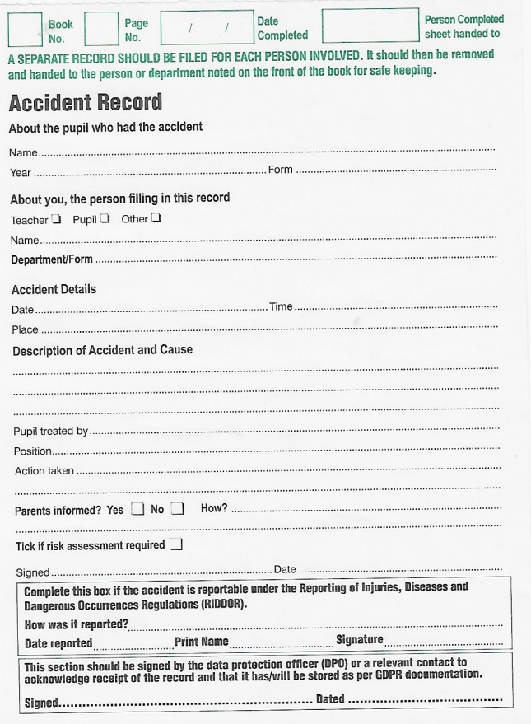

*Appendix II – Pupil Major Accident Form (to be handed to school leader).*

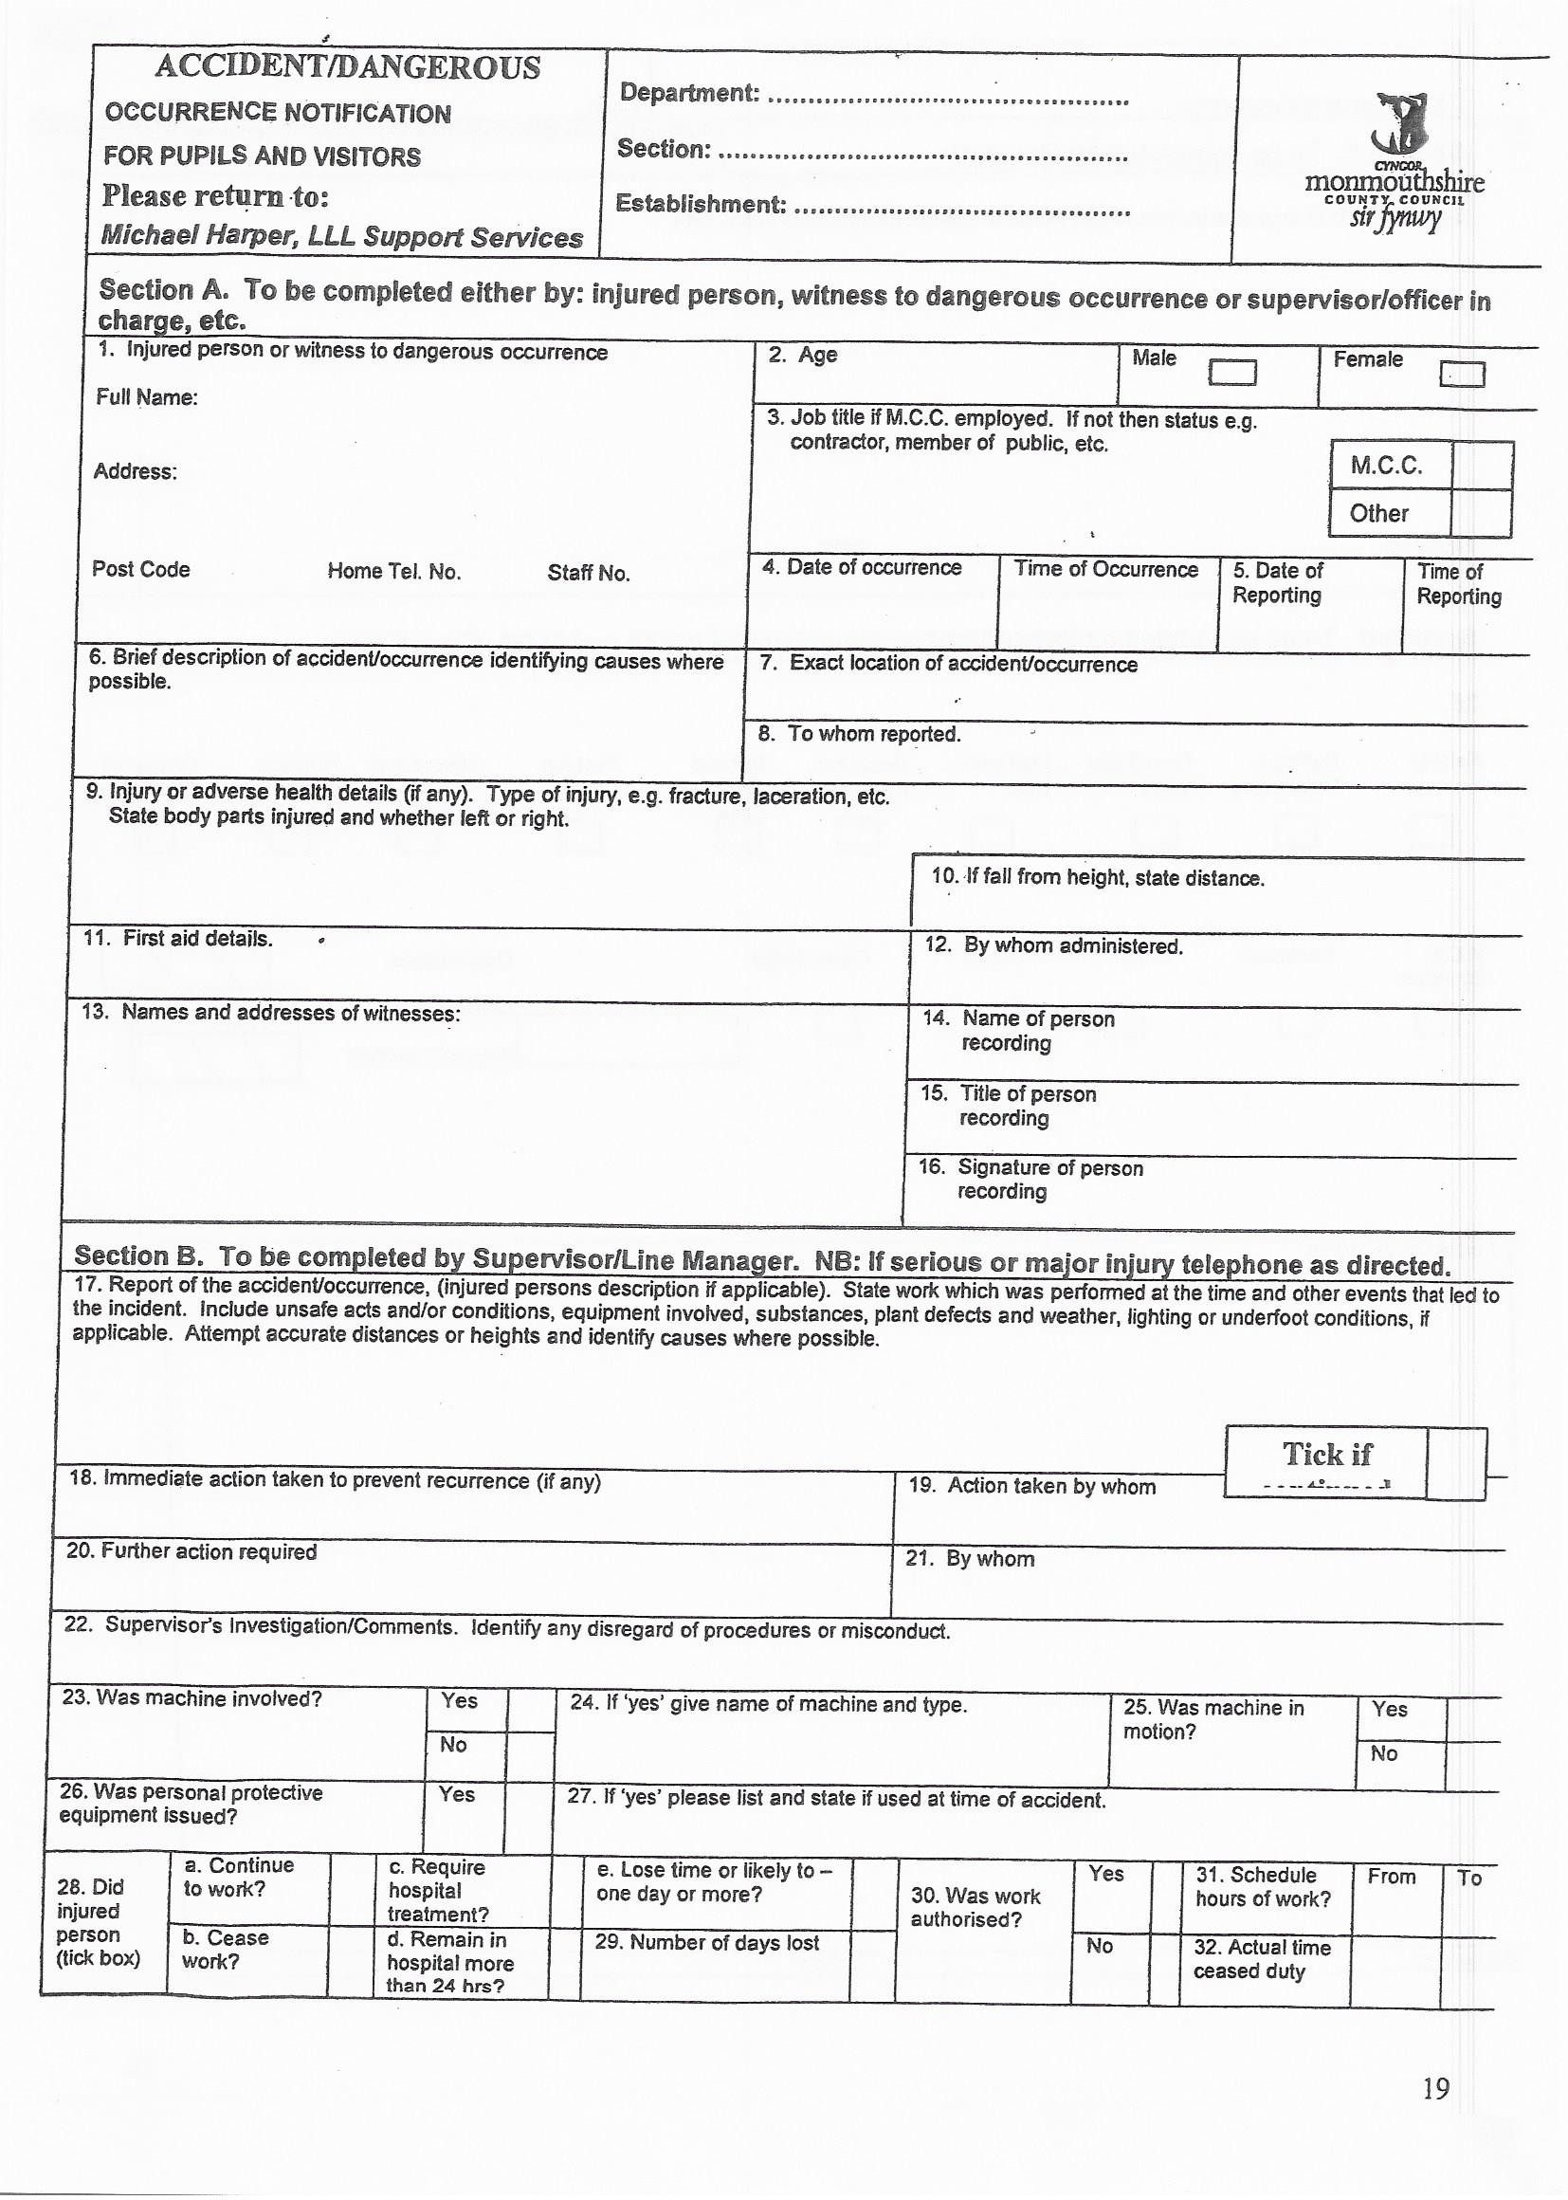



**Administering of Medicines Policy**

**Medicines in School**

We have established a procedure for administering medicines in school. This is necessary to ensure the safety of all the children in our care.

As a general policy staff at Overmonnow Primary School will administer prescribed medicines to children at school, this must be proceeded by the completion of relevant paper work and in some cases will need the input of a school nurse or doctor. **This policy applies to prescription medicines only, non-prescribed medicines will not be administered and must not be given to or taken by children in school.**

The circumstances in which medicines may be administered by a member of staff are as follows:

1. The medicine must have been prescribed by the child’s doctor;
2. Where medication requires more than one dosage we would expect doctors to prescribe 3 daily doses to be taken three times a day outside school hours for example antibiotics. Where this is not possible the relevant paper work has to be completed.
3. Signed consent must be given by the adult with parental rights for the child (see form on next page);
4. The head teacher must be informed of the intention to administer medicines in school and sign the agreement;
5. Medicine must be clearly labelled in a child-proof container and kept in a safe place out of the reach of children;
6. Medicine must not be kept in public areas or in a child’s bag;
7. Children must be supervised by two members of staff when medicine is administered, they must not be allowed to administer medicine on their own;
8. Throat tablets that are brought into school must be clearly labelled, kept by the classteacher. Only the allotted amount needs to be brought in.



***OVERMONNOW PRIMARY SCHOOL***

***PARENT/CARER CONSENT FOR SCHOOL TO ADMINISTER MEDICATION TO A PUPIL***

* Our school **will not give** your child medication unless you complete and sign this form.
* If more than one medication is to be given, a separate form should be completed for each one.
* A new form must be completed when dosage changes are made.
* Where medication is prescribed to be taken in frequencies which allow the daily course of medicine to be administered at home, parents should seek to do so, e.g. before and after school and in the evening. (However we understand there will be instances where this is not appropriate.)
* Parents/carers will be informed as stated in the school policy when a child refuses their medication or when emergency medication is administered.
* Parents/carers can request sight of records.
* Without exception pupils must not share their medication for any reason with another pupil.

|  |  |  |  |  |
| --- | --- | --- | --- | --- |
| Name of child |  | | | |
| Date of birth |  | | | |
| Class / form |  | | | |
| Healthcare need |  | | | |
| Routine or emergency medication |  | | | |
| **Medicine** |  | | | |
| **Note: medication must be in the original container if dispensed by the pharmacy.** | | | | |
| Name, type and strength of medicine *(as described on the container)* |  | | | |
| Date dispensed |  | | | |
| Expiry date |  | | | |
| Dose and frequency of medication |  | | | |
| Method of administration |  | | | |
| Timing of medication |  | | | |
| Duration of treatment |  | | | |
| Special precautions |  | | | |
| Special requirements for administering medication e.g. two staff present, same gender as pupil. |  | | | |
| Storage requirements |  | | | |
| Who will deliver the medication to school and how frequently? |  | | | |
| Who will receive the medication? |  | | | |
| Does treatment of the medical condition affect behaviour or concentration? |  | | | |
| Are there any side effects that the school needs to know about? |  | | | |
| Is there any medication that is being administered outside of school day that we need to know about?  Are there any side effects that we should be aware of? |  | | | |
| Any other instructions |  | | | |
| Pupil to self-administer medication  under supervision from a stored location | Yes / No | (please circle)  *If yes, pupil must also sign declaration\** | | |
| Pupil to carry and self-administer medication | Yes / No | (please circle)  *If yes, pupil must also sign declaration\** | | |
| Procedures to take in an emergency |  | | | |
| **If** the school has an emergency inhaler-    If your child is prescribed an inhaler have you given consent for your child to use a school emergency inhaler on a separate consent form? | Yes / No       (please circle) | | | |
| Agreed review date | *To be completed with the school* | | | |
| Name of member of staff responsible for the review | *To be completed with the school* | | | |
| **INDIVIDUAL HEALTHCARE PLANS (IHP)** | | | | |
| Healthcare Plan from health professional attached if appropriate | Yes / No | (please circle) | | |
| IHP created by school attached if appropriate (appendix 3) | Yes / No | (please circle) | | |
| Guidelines provided by health attached if appropriate e.g. patient information sheet | Yes / No | (please circle) | | |
| Review date of the above |  | | | |
| **Contact details** | **Contact 1** | | | **Contact 2** |
| Name |  | | |  |
| Daytime telephone number |  | | |  |
| Relationship to the child |  | | |  |
| Address |  | | |  |
| Post Code |  | | |  |
| In the best interests of the pupil the school might need to share information with school staff and other professionals about your child’s healthcare needs e.g. nursing staff.    Do you consent to this information being shared? | Yes / No | | (please circle) | |
| * I have read and agree to the school giving medication in accordance with the school policy. I understand my parental/carer obligations under the Welsh Government guidelines (<http://learning.gov.wales/resources/browse-all/supporting-learners-with-healthcare-needs/?skip=1&lang=en>). * The above information is, to the best of my knowledge, accurate at the time of writing and I give consent to school staff to administer the medicine in accordance with the information given above and the school policy. * I will inform school of any new information from health professionals in regard to my child, e.g. if there are any changes in dosage or frequency or if it is stopped. I will ensure that this is in writing from the health professional. * I understand that it is my responsibility to replenish the medication supply in the school and collect expired or unused medication. * Where correct medication is not readily available on a given day and places the child at risk, the head teacher has the right to refuse to admit my child into the school until said medication is provided. * It is my responsibility to provide in-date medication which is correctly labelled. * I consent for the information in the form to be shared with health professionals/emergency care. * If my child has received any emergency medication prior to school, I will inform the head teacher/delegated member of the school staff before school starts. | | | | |
| Parent/carer signature: |  | | | |
| Date: |  | | | |

I would like my child to administer and/or carry their medication

|  |  |
| --- | --- |
| Parent/carer signature: |  |
| Date: |  |

*If yes to these questions: I agree to administer and/or carry my medicine.  If I refuse to administer my medication as agreed, then this agreement will be reviewed.

|  |  |
| --- | --- |
| Pupil signature: |  |
| Date: |  |

**\*\*\*\*\*\*\*\*\*\*\*\*\*\*\*\*\*\*\*\*\*\*\*\*\*\*\*\*\*\*\*\*\*\*\*\*\*\*\*\*\*\*\*\*\*\*\*\*\*\*\*\*\*\*\*\*\*\*\*\*\*\*\*\*\*\*\*\*\*\*\*\*\*\*\*\*\***

**HEADTEACHER/DELEGATED PERSONS AGREEMENT TO ADMINISTER MEDICATION**

It is agreed that <*insert child’s name*>   will receive <*insert name and quantity of medication*>  at <*insert time medicine is to be administered*>

(Name of pupil) will be given their medication / supervised while they take their medication by <*insert name of member of staff>*

This arrangement will continue until (*e.g. either end date if course of medication or until instructed by parents/carers)*

Name (head teacher/delegated person):

Signed: Date:

 Individual Healthcare Plan in place; OR

 Individual Healthcare Plan not required



**Asthma – School Policy and Protocol**

**Signs and symptoms to be aware of**:

* Coughing
* Shortness of breath
* Wheezing
* Tightness in the chest
* Being unusually quiet
* Difficulty speaking in full sentences
* Sometimes younger children will express feeling tight in the chest as a tummy ache

**Medication and Treatment**:

* Reliever inhalers (usually blue) – essential for treating asthma attacks
* Must be available to the child at all times.
* *This medicine is very safe. During an asthma attack do not worry that a pupil may overdose.)*
* Preventer inhalers (usually brown, beige, orange, red or white) – these are usually kept at home.
* Other medication
* Some children may need to use their inhaler before exercise

**Minor Asthma attack**

* Minor attacks should not interrupt the involvement of a child with asthma in school.
* Mild asthma symptoms will usually resolve following 2-4 puffs of reliever inhaler.
* When the child feels better they can return to school activities.
* The parents must always be told if their child has had asthma symptoms. That is if they have had to use their inhaler more than twice in one day.

**Severe symptoms**

* **Keep calm – do not panic**
* Encourage the child to sit up and forward – ***do not*** hug or lie him/her down
* Make sure the pupil takes a further 2 puffs of their inhaler (usually blue), via spacer device if it is available
* Ensure tight clothing is loosened
* Reassure the child
* Contact Parents/Legal Guardia



**Asthma Medication Consent Form**

Please can you complete these forms and return them to the school office as soon as possible.

(Please refer to the Privacy Notice, which can be found here [www.overmonnow.monmouthshire.sch.uk](http://www.overmonnow.monmouthshire.sch.uk) which details why we are collecting this information, how we will keep this information safe and how you can withdraw your consent to us holding this information)

**PLEASE COMPLETE THIS FORM IF YOUR CHILD HAS BEEN DIAGNOSED WITH ASTHMA OR USES AN INHALER. IT IS IMPORTANT THAT WE HAVE THE CURRENT MEDICAL DETAILS FOR YOUR CHILD**.

|  |  |
| --- | --- |
| **Pupil Details** | |
| **Surname\*** |  |
| **Forename\*** |  |
| **Class** |  |

|  |  |
| --- | --- |
| **Medical Information** | |
| **Name of Doctor:\*** |  |
| **Name of Surgery:\*** |  |
| **Address of Surgery:** |  |
| **Telephone Number of Surgery:** |  |
| **MEDICATION** | |
| **Reliever and dosage** |  |
| **Preventer and dosage** |  |
| **Any further actions required:** |  |

|  |  |
| --- | --- |
| **EMERGENCY SALBUTAMOL/VENTOLIN INHALERS** | |
| **The school holds a salbutamol (Ventolin) inhaler for use in an emergency, together with an individual disposable spacer, as a back-up if your child’s inhaler is not working or is not present in school**  **If you wish your child to use this emergency inhaler, then please complete the information below.**  **If your child requires the use of this inhaler, a letter will be sent home giving full details of the episode and dosage used.** | |
|  | |
| **I confirm that my child has been diagnosed with asthma** **Yes / No (delete as appropriate**) | |
| **My child will have a working, in-date inhaler, clearly labelled with their name, which they will bring with them to school every day.** | |
| **In the event of my child displaying symptoms of asthma and their inhaler is not available or unusable, I consent for my child to receive salbutamol (Ventolin) from an emergency inhaler held by the school for such emergencies.** | |
| **Signed:** |  |
| **Date:** |  |
| **Parent/Guardian full name (PRINT):** |  |
| **Parent/Guardian mobile number:** |  |
| **Parent/Guardian Home / work number:** |  |
| **Parent/Guardian address:** |  |